Model building SIN, Ops Ol, day step

Liz Allyn

2023-06-29

Summary

This doc is for exploring a preliminary model that captures the dynamics of seals switching between behavioral states. These states are normal seals (N) which behave and eat like an average Puget Sound seal and largely exist outside the Locks system, but still provide a source population; specialist seals (S) who are actively targeting salmon at the Locks, and inactive specialists (I) who have been specialists in the past or been exposed to that behavior, but are not actively exercising it for various reasons. We also capture the movement of salmon through the system as either salmon moving through Puget Sound (Ops) and salmon that have reached the Locks (Ol) and are there for some residence time (per species - starting with adult Chinooks for now). The time step for this model is 1 day. Lots of the parameters are guesstimates and totally made up but I’ll add data source info as I add real data later on.

## Load packages and functions

source("/Users/lizallyn/Documents/GitHub/Thesis/Pinniped Case Studies/Functions/functions.R")  
source("/Users/lizallyn/Documents/GitHub/Thesis/Pinniped Case Studies/Functions/Sockeye arrival function creation.R")

##   
## Attaching package: 'dplyr'

## The following objects are masked from 'package:stats':  
##   
## filter, lag

## The following objects are masked from 'package:base':  
##   
## intersect, setdiff, setequal, union

### Version 2

# for leaving and switch function  
leave_threshold <- 50 # this we can estimate from diet data I bet - how much does a salmon specialist eat? If anything less than that is available, then they would leave the S group?  
leave_steepness <- 0.2 # this is probably very steep - almost a yes or no there is/isn't enough salmon  
  
switch_threshold <- 500 # again I bet we can find a good starting point from diet data  
switch_steepness <- 0.05  
  
# removals  
Hunt.N <- 0  
Hunt.I <- 0  
Hunt.S <- 0  
  
# discovery  
d <- 0.00000001 # total BS right now, need a better approach that isn't a total guess  
  
# predation  
dailyconsumption <- 5 # also BS right now  
  
# movement rate above the locks (basically 1/residence time)  
ladder <- 0.3  
  
# for loop  
nruns <- 365  
daysofyear <- 1:365

Starting values, mostly random or NA or 0. 150 seals at I bc that’s the approximate size of the Elliot Bay marina haulout at max 13500 normal seals because that’s about the total inland waters estimate from 1999

Ops is 1 million for no good reason.

# starting values for S, I, N, Ops, Ol  
S <- rep(NA, nruns)  
I <- rep(NA, nruns)  
N <- rep(NA, nruns)  
  
Ops <- rep(NA, nruns)  
Ol <- rep(NA, nruns)  
Osafe <- rep(NA, nruns)  
salmon.arrive <- rep(NA, nruns)  
  
S.switch <- rep(NA, nruns)  
S.leave <- rep(NA, nruns)  
S.arrive <- rep(NA, nruns)  
  
discovery <- rep(NA, nruns)  
  
removals.N <- rep(NA, nruns)  
removals.I <- rep(NA, nruns)  
removals.S <- rep(NA, nruns)  
  
S[1] <- 0  
I[1] <- 150  
N[1] <- 13500  
  
Ops[1] <- 1000000  
Ol[1] <- 0  
Osafe[1] <- 0  
salmon.arrive[1] <- 0  
  
S.switch[1] <- 0  
S.leave[1] <- 0  
S.arrive[1] <- 0  
  
discovery[1] <- NA  
  
removals.N[1] <- 0  
removals.I[1] <- 0  
removals.S[1] <- 0

Ops starts at an arbitrary 1 million salmon in Puget Sound.

ladder = 0.3 means it takes about 3 days for a salmon to go from arriving to safe. This lines up with what Eric and Ava said for Sockeye, but very different for Chinook and not known for coho.

for (t in 2:nruns) {  
 salmon.arrive[t] <- predict.fish(day = t, params = fish.fit.optim$par, start.day = 163)  
 Ops[t] <- Ops[t-1] - salmon.arrive[t]  
   
 #predation <- min(Ol[t-1], predation.rate(seals = S[t-1], consumption = dailyconsumption))  
 predation <- 0  
 salmon.leave <- ladder * Ol[t-1]  
 Ol[t] <- salmon.arrive[t] - predation  
 Osafe[t] <- Osafe[t-1] + salmon.leave  
  
 discovery[t] <- discovery.rate(seals = N[t-1], salmon = Ol[t-1], d = d)  
 removals.N[t] <- Hunt.N*N[t-1]  
 N[t] <- N[t-1] - discovery[t] - removals.N[t]  
   
 S.switch[t] <- I[t-1] *  
 switch.rate(salmon = Ol[t-1],   
 threshold = switch_threshold,   
 steepness = switch_steepness)  
 S.leave[t] <- S[t-1] *   
 leaving.rate(salmon = Ol[t-1],   
 seals = S[t-1],   
 threshold = leave_threshold,   
 steepness = leave_steepness)  
 S[t] <- S[t-1] + S.switch[t] + discovery[t] - S.leave[t]  
 I[t] <- I[t-1] + S.leave[t] - S.switch[t]  
}  
  
par(mfrow = c(1,2))  
plot(daysofyear, N, type = "l", col = "black", main = "normal")  
plot(daysofyear, S, col = "salmon3", main = "specialists", type = "l")

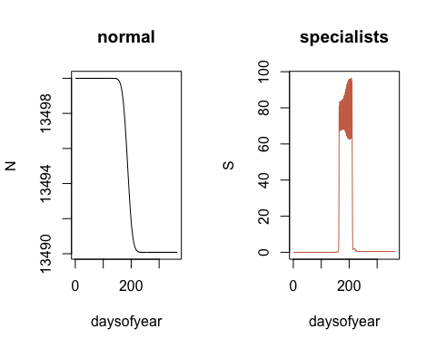

plot(daysofyear, I, col = "orchid3", main = "inactive", type = "l")  
plot(daysofyear, S.arrive, col = "salmon3", main = "arrive", type = "l")

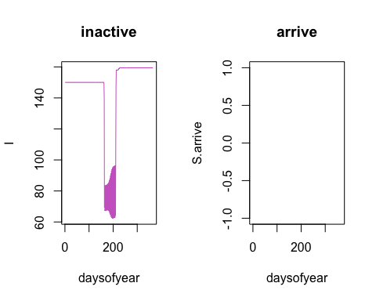

plot(daysofyear, S.leave, col = "salmon3", main = "leave", type = "l")  
plot(daysofyear, discovery, col = "salmon3", main = "discovery", type = "l")

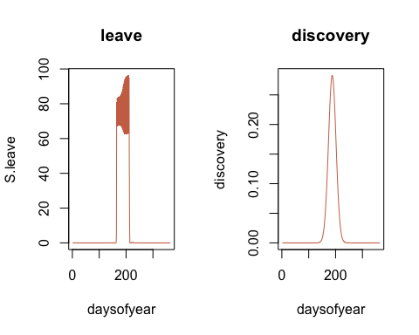

plot(daysofyear, Ol, col = "turquoise3", main = "Locks salmon", type = "l")  
plot(daysofyear, Ops, col = "dodgerblue", main = "PS salmon", type = "l")

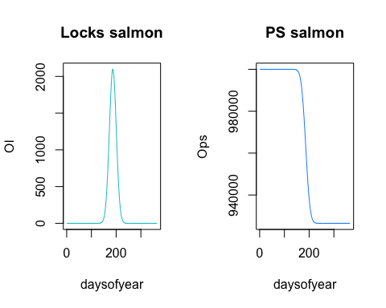

plot(daysofyear, salmon.arrive, col = "turquoise3", main = "Arriving salmon", type = "l")  
plot(daysofyear, Osafe, col = "dodgerblue", main = "Safe salmon", type = "l")

